**PROCESS INSTRUMENTATION**

**Name: Vivek Chandrashekhar Rugale**

**GR No.: 11810369**

**Div.: TY-C**

**Roll No.: 24 (Batch B1)**

**LAB 6:**

**Aim - Study of conventional and intelligent temperature transmitters**

Implementation of RTD Intelligent transmitter features (voting and averaging logic) using Python:

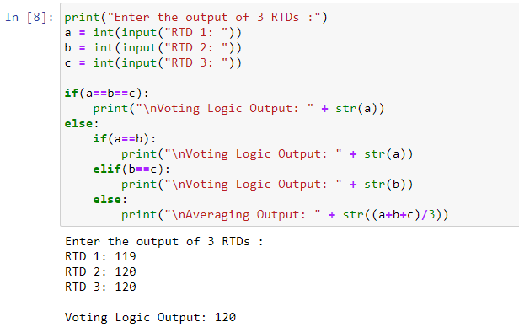

Averaging:

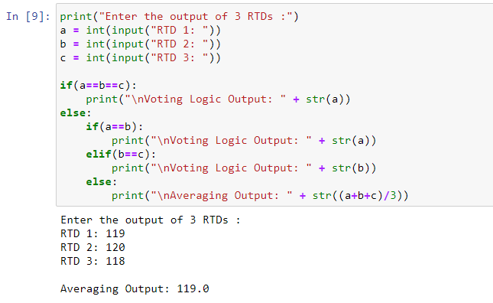

**Conclusion:**

Studied conventional and intelligent temperature transmitters. Implemented voting and averaging logic of intelligent transmitters using python programming.